**VIEWS AND INDEX ASSIGNMENT**

**Student Table :**

1. Primary key :

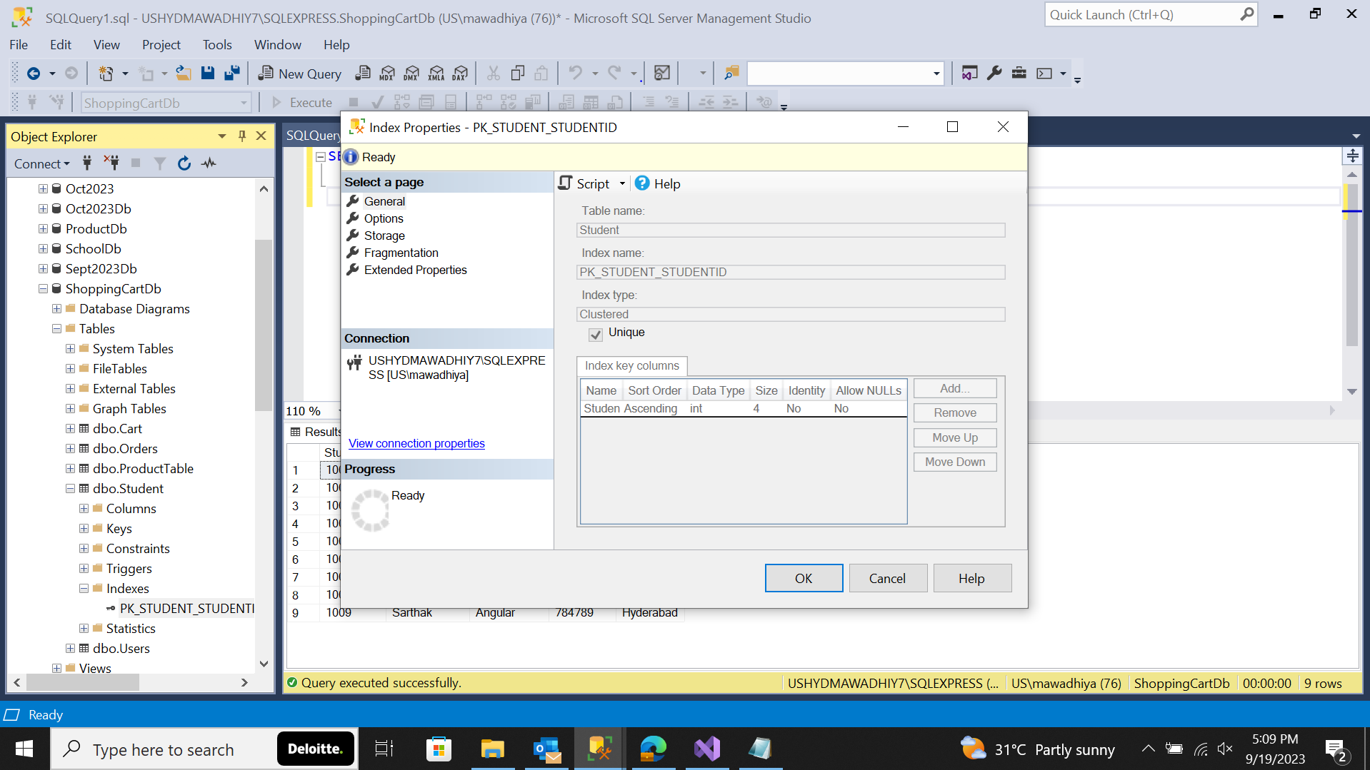

1. Non – Clustered Index

1. Composite Index

1. A. Drop Index

b. RENAME

c. ENABLE and DISABLE

1. Checking all index

**VIEWS :**

2.

4.

